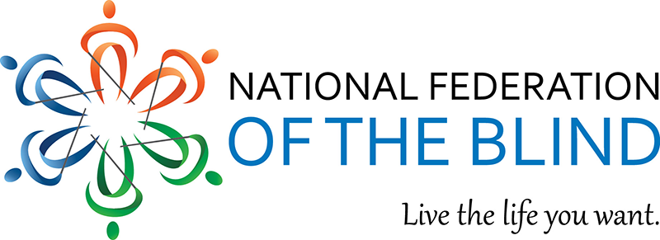

December 4, 2024

**Dear Friend of visually impaired persons,**

I am eager to invite you to the **National Federation of the Blind (NFB) of Greater Springfield Inc. chapter Annual Walk** on **Saturday, May 31st**, from **9:00 a.m. to 2:00 p.m.**, at the Van Horn Park, 910 Liberty Street Springfield, MA. Last year, thanks to contributions from supporters like you, we raised over $1,400 which enabled us to do the following:

* **Scholarships:** We provided scholarships to assist two blind students in their pursuit of higher education.
* **Advocacy:** Members of the Springfield Chapter met with the Massachusetts Congressional delegation on Capitol Hill as part of the NFB Washington Seminar.
* **Leadership Development:** We supported and participated in seminars designed for emerging leaders and blind students.
* **Communication:** Design new chapter website to be launched in early 2025

Please mark your calendar for **Saturday, May 31st** and join us for a morning filled with fun, friendship, and fundraising. We’ll be walking at the Van Horn Park located behind the chapter house.

You can support our local visually impaired in several ways: the annual walk, identifying sponsors, sponsoring a participant, or donating a gift card. If you are unable to attend but would still like to contribute, please **make checks payable to NFB of greater Springfield Inc.** and mail them to **P.O. Box 3512 Springfield, MA 01101**. Donations can also be made online via credit card or PayPal at **nfbmags.org**. Please indicated that your gift is for the **NFB of GS Walk**, **remitted by December 1, 2025.**

If you have any questions or would like any additional information, please call me, President and Walk Coordinator at 413-887-4376. Thank you for helping the visually impaired.

Sincerely,

Theadora Williams

Theadora Williams, President

NFB of Greater Springfield Inc. Chapter

P.O. Box 3515 Springfield, MA 01101

Taxpayer ID number: 046071412