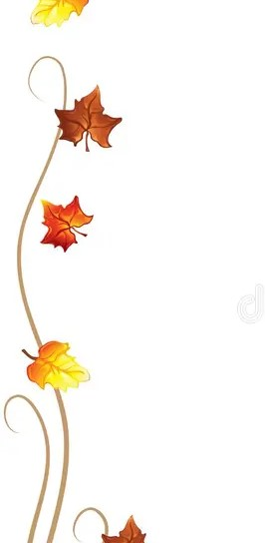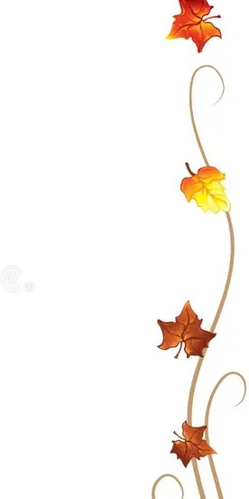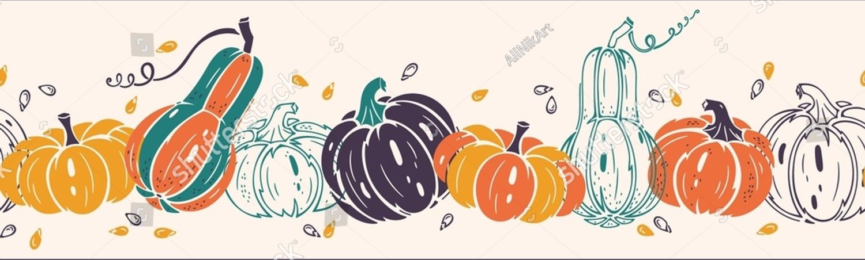

Fun at our holiday

craft/vendor fair

**Sunday November 23**

**10 A.M. – 3 P.M.**

At the Moose Lodge 244 Fuller Road Chicopee

hosted by **the National Federation of the Blind of Greater Springfield Inc.**

**website** [**www.nfbmags.org**](http://www.nfbmags.org)

Raffle prizes join us for some holiday fun shopping!

Plus, customer appreciation raffle.